Issue | Image
Landing Page
“See How It Works” and “Choose your role to get started” are overlapping each other. Please adjust spacing. | 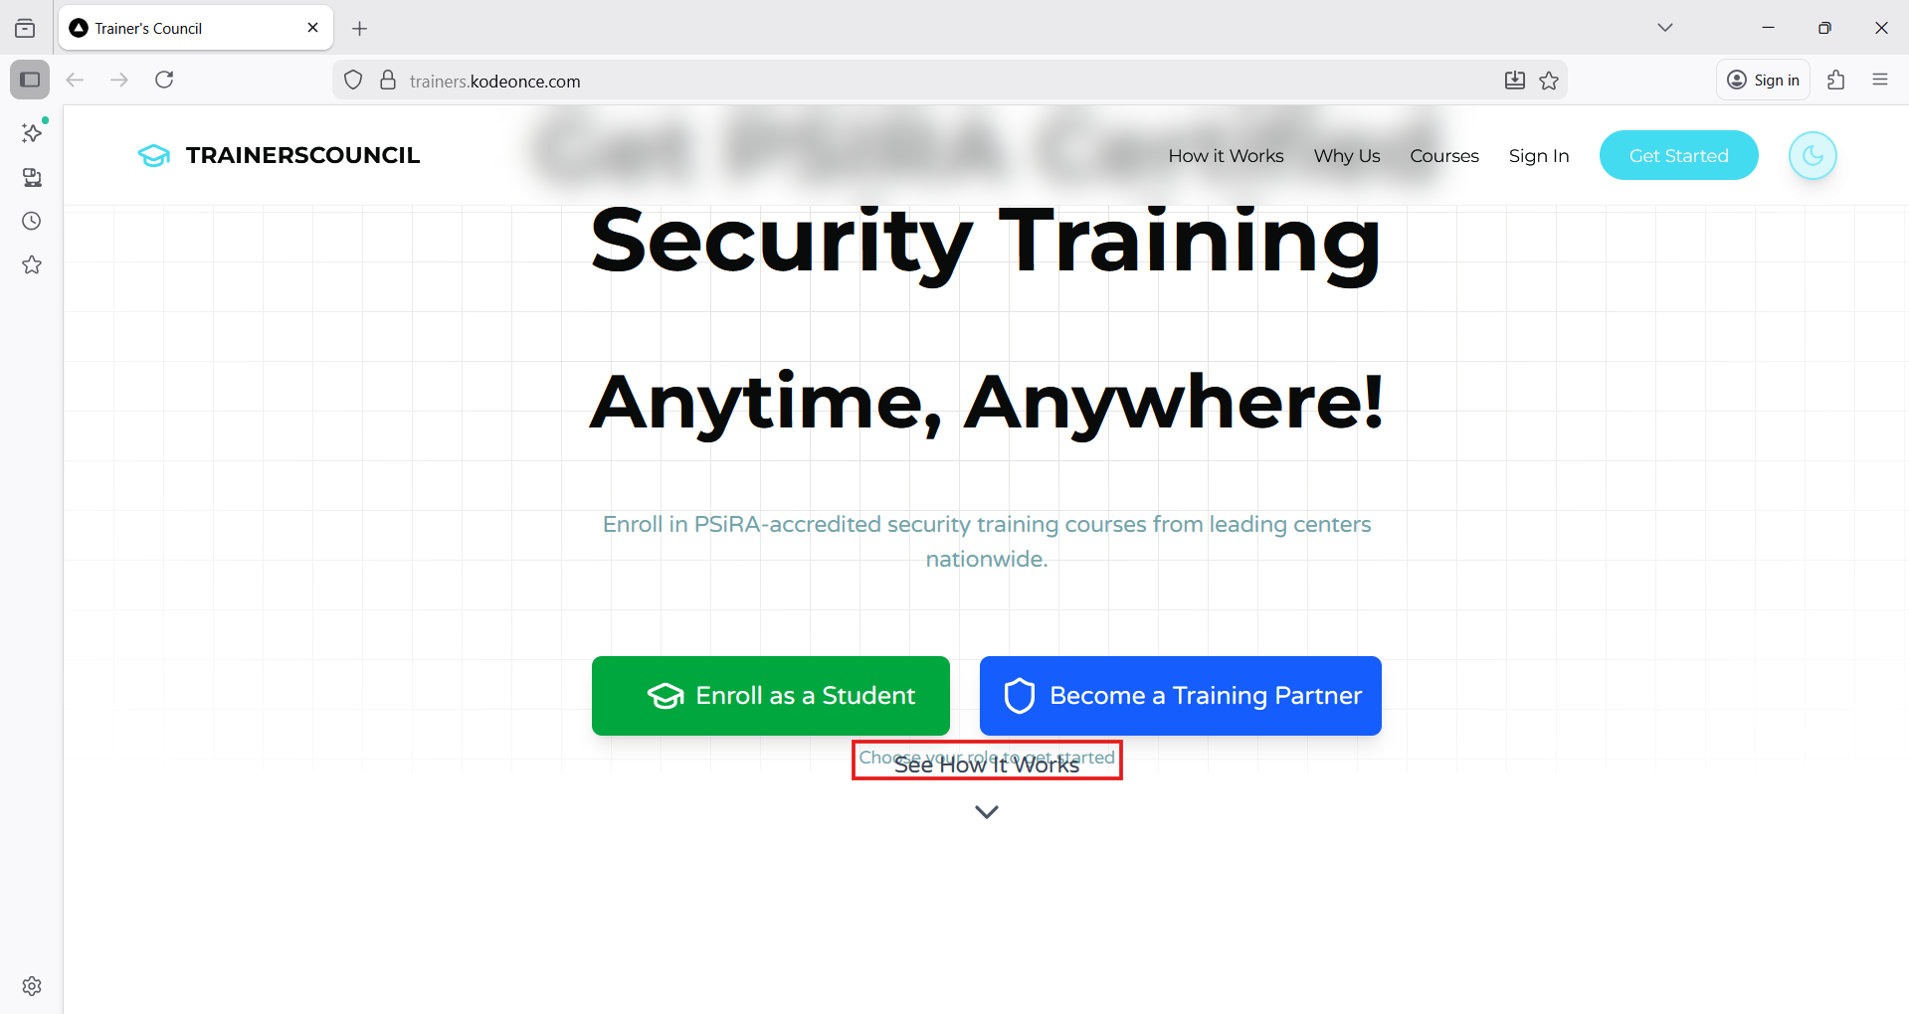
Toward the end, two tiles are repeated and fade away. Please can this be removed.  Tiles are not the same size. Please can this be adjusted for a more uniform look? | 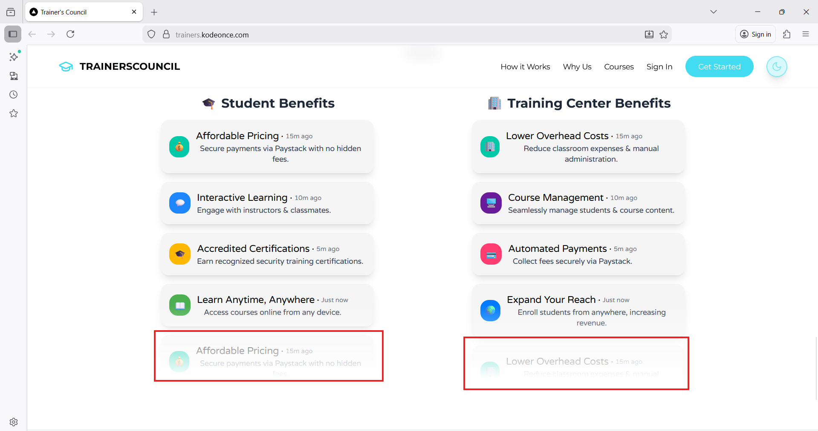
Clicking on these tabs do not take the user to either the Enrollment or Becoming a Trainer page.  Please can this be linked to the respective pages? | 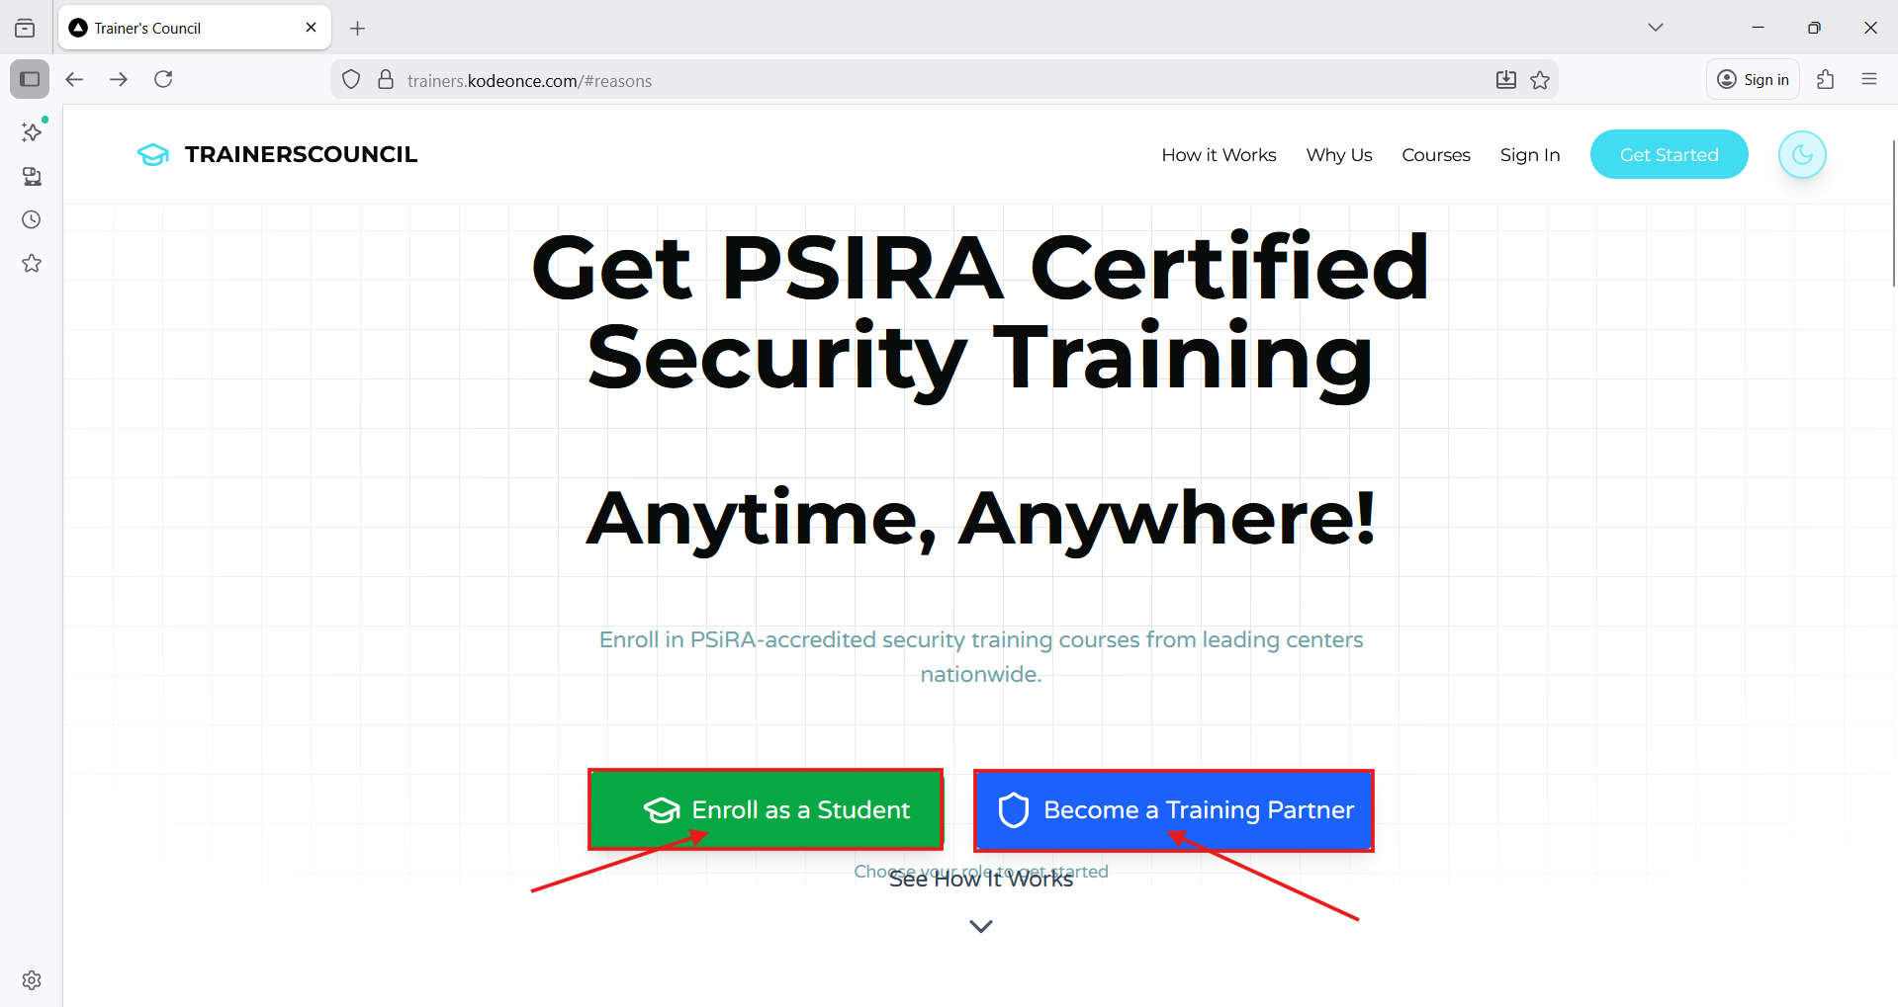
Admin Profile
Page 1 of 1:  Under the Dashboard, information cannot be typed under filter tasks. How does this work? | 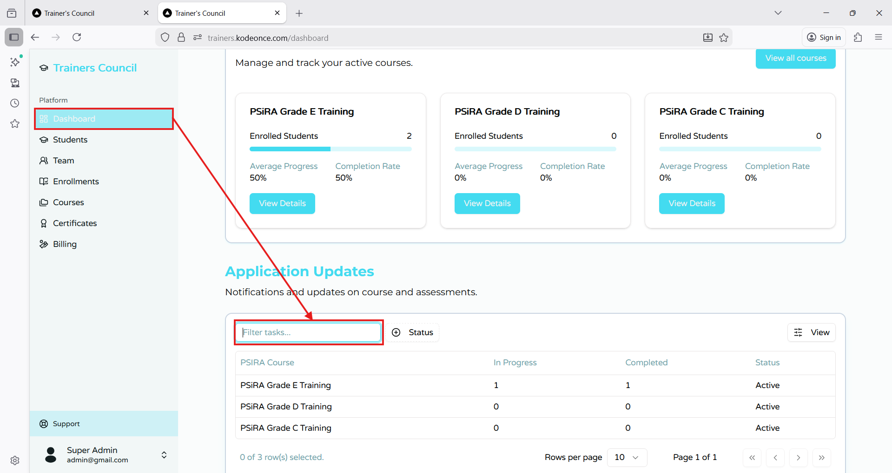
Page 1 of 1:  Under the Dashboard, the status of “Active” or “Inactive” cannot be ticked.  This has to be typed into the search bar in order to be selected.  Can this be changed to a tick box selection in order for convenient filtering since there are only two options? | 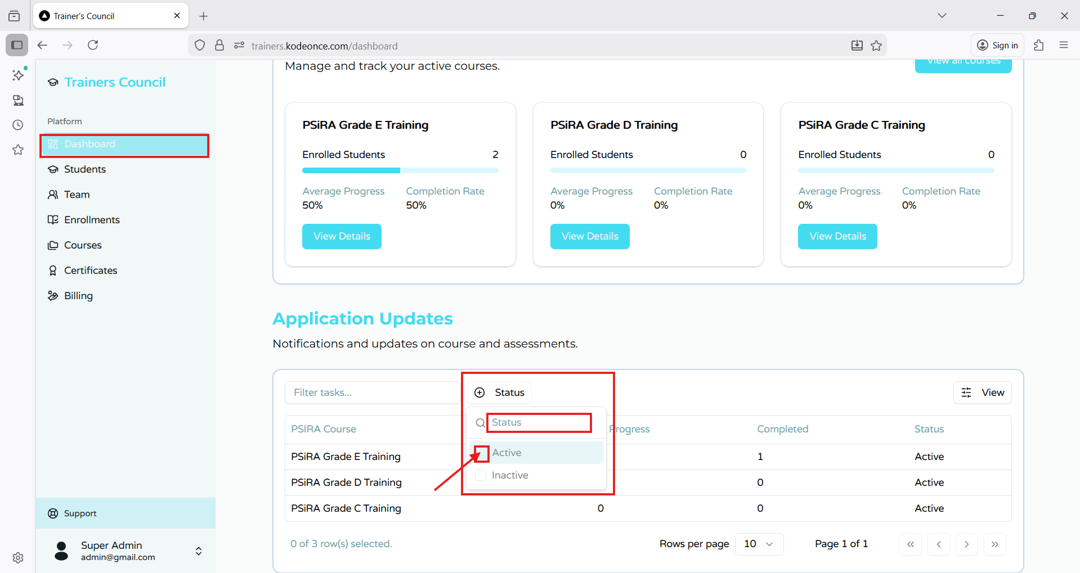
Students tab:  Please can this read “Students” instead of “Student”. | 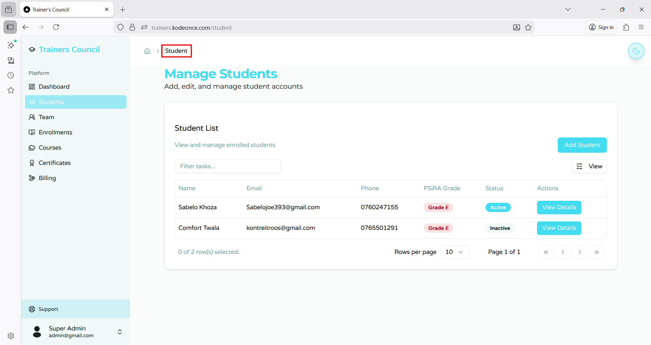
Students tab:  Unable to type into “Filter tasks…”  Please explain how this feature is used.. | 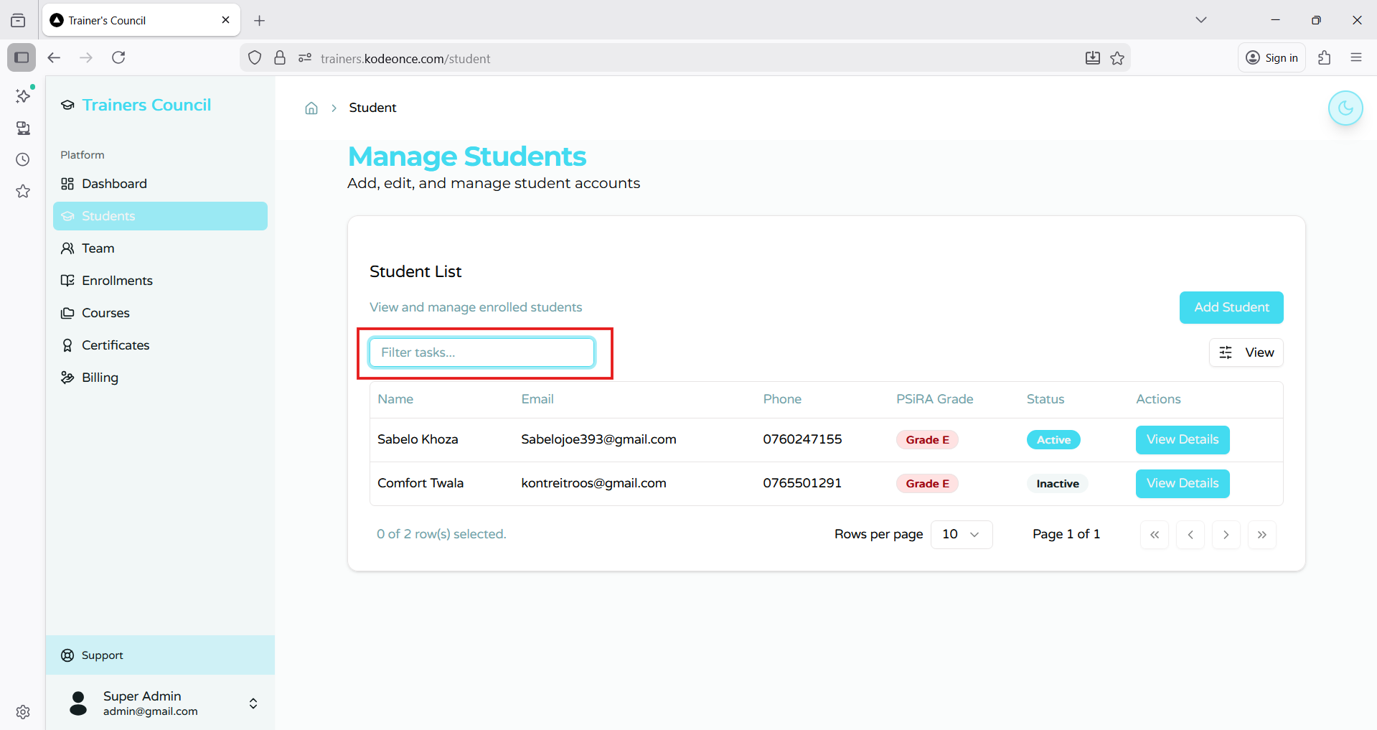
Students tab:  When viewing a Certificate of a student who has achieved the required courses.. a 404 error occurs. | 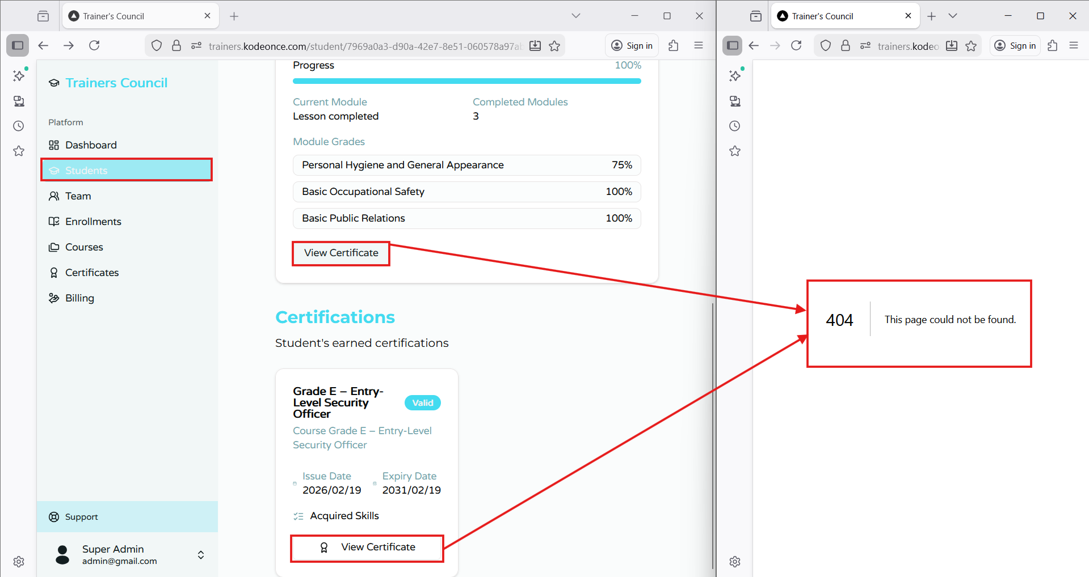
Team tab:  Next to “Date Added”, what are the letters and numbers? | 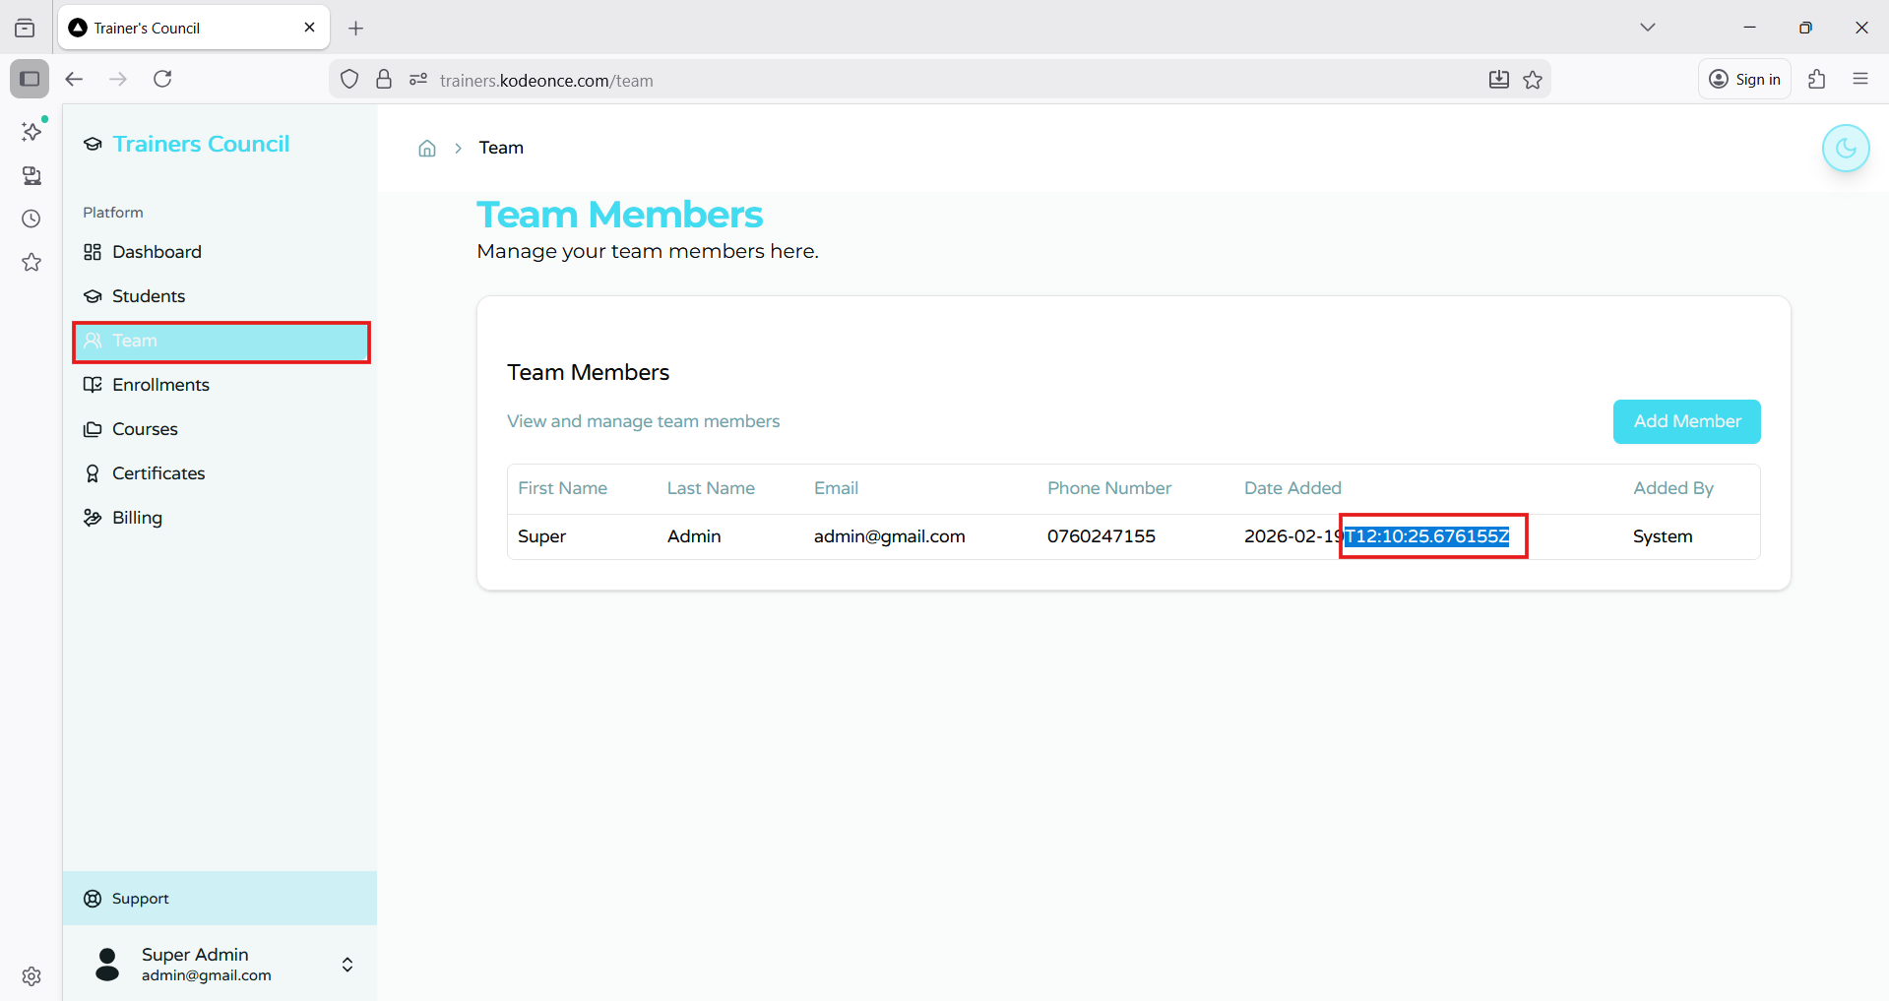
Team tab:  How would you go about removing a member? | 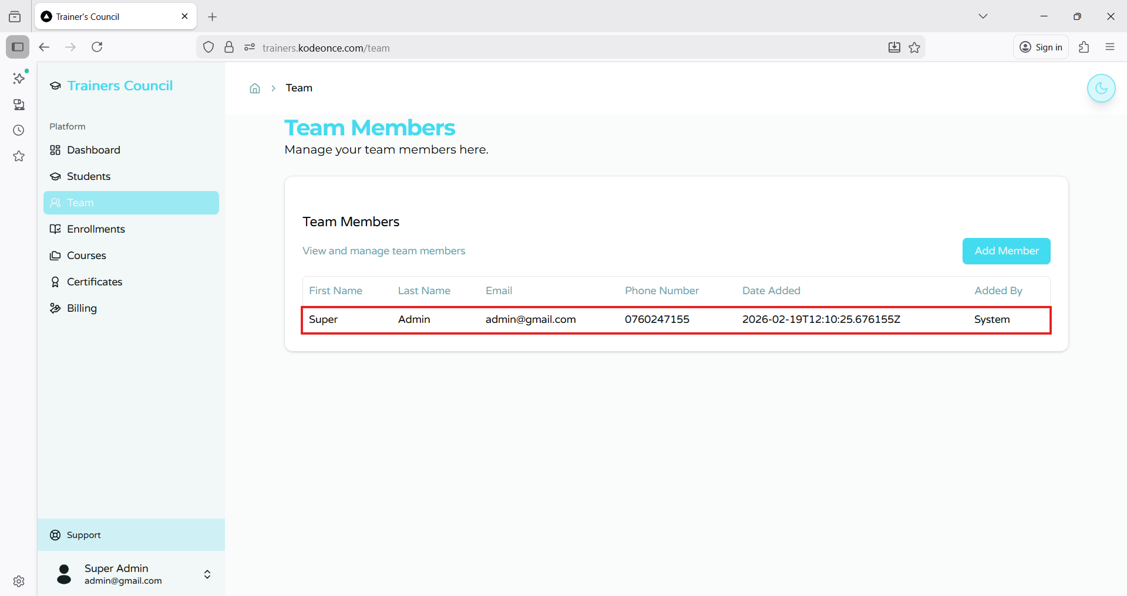
Enrollments tab:  Please explain student ID’s. | 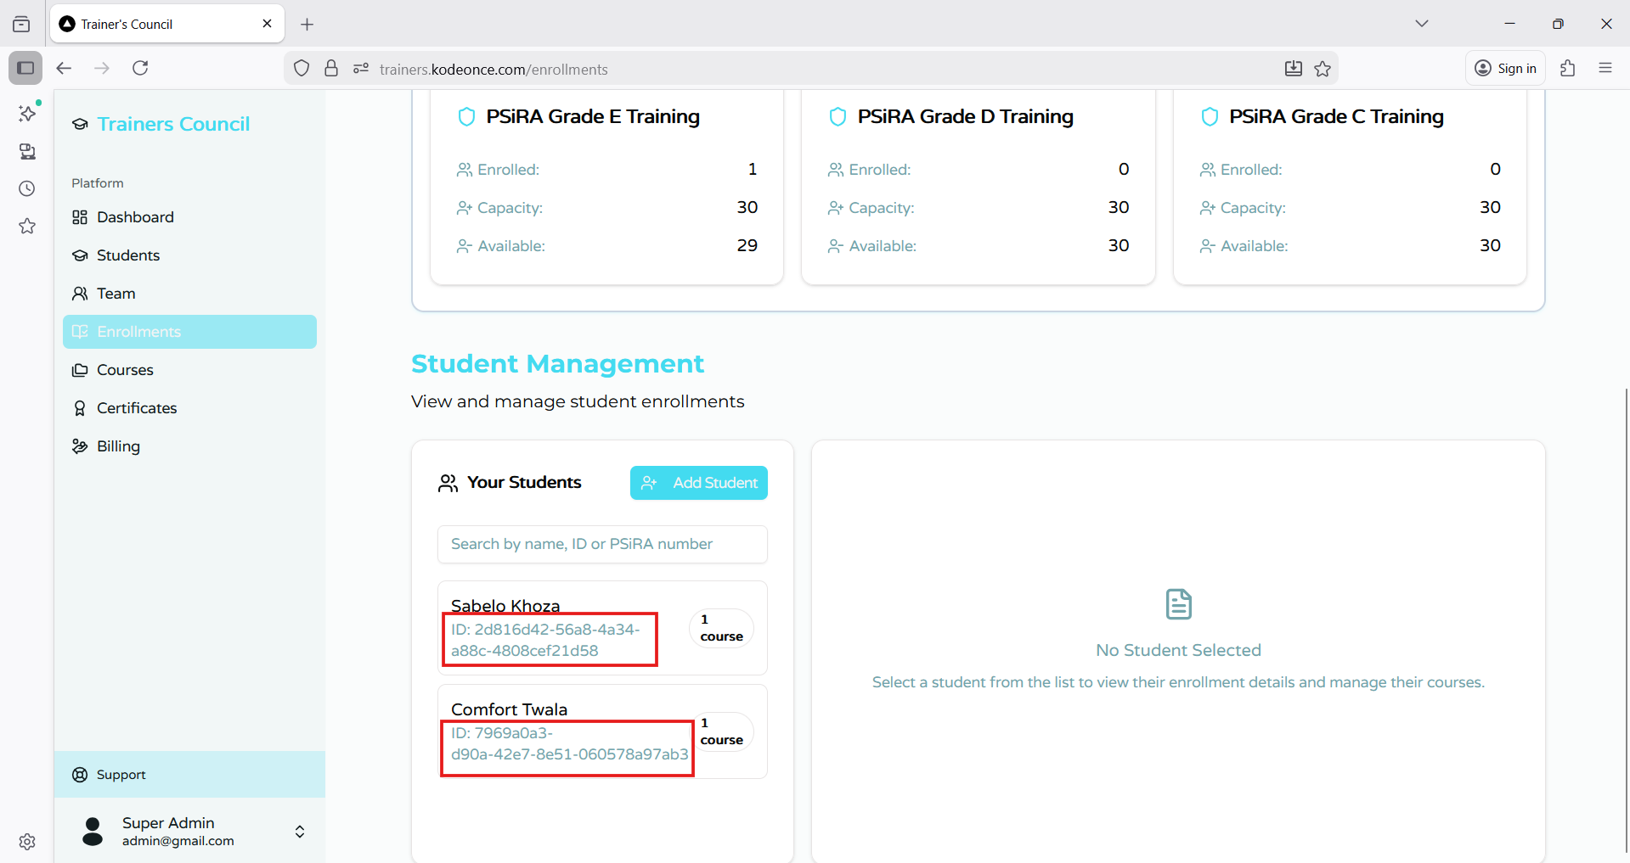
Enrollments tab:  Student Management has a “settings” icon. When clicked, nothing happens.  What is the significance of this? | 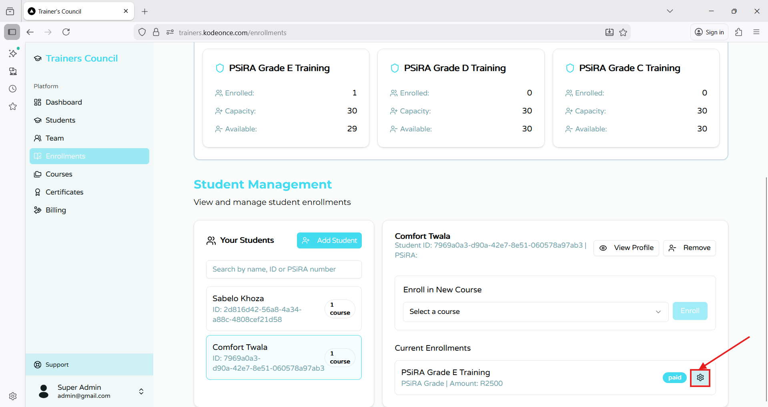
Student Profile
Certificates:  No expiry date on training certificates. This is life long valid. | 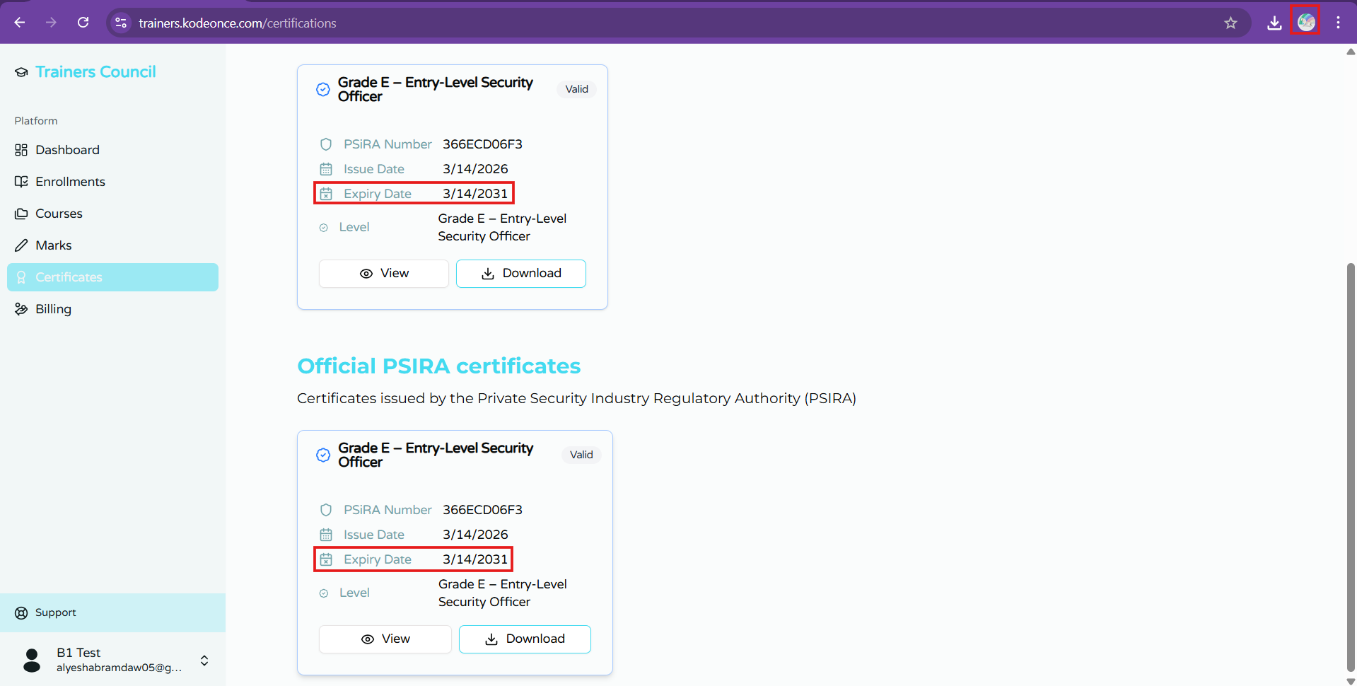
Notifications and Settings:  When either is clicked nothing happens. | 